OFFICIAL COORDINATION REQUEST FOR
NON-ROUTINE OPERATIONS AND MAINTENANCE

COORDINATION TITLE: 13BON51 NDE Lamprey Flume repairs
COORDINATION DATE- 24 July 2013
PROJECT- Bonneville Lock and Dam – Washington Shore Fish Ladder
RESPONSE DATE-

Description of the problem- During the 2012-2013 IWW period, the Corps of Engineers (COE) installed a prototype adult Pacific lamprey passage structure designed to improve lamprey passage at the Bonneville WA Shore north downstream entrance. Shortly following installation, one of the rods that provides structural support for the new Lamprey Flume System (LFS) failed, prompting installation of temporary bracing for adjacent rods and an investigation of the problem (Figure 1). COE determined that vibration due to unanticipated hydraulic loading fatigued the broken rod and adjacent rods and that the mounting system for the LFS must be revised no later than Winter 2013-2014 to avoid complete failure of the system.

The COE design team and a contractor are working on a revised design for the mounting system, but details on this design and the required construction schedule are not yet available. As such, COE must estimate, based on previous experience with LFS installation in the Powerhouse 2 tailrace, operational requirements for construction. In addition to the mounting system modifications, COE intends to address a variety of smaller-scale modifications to the LFS and adjoining Lamprey Passage Structure (LPS) during the requested outage. These include securing HDX-PIT antenna conduit, installation of permanent LPS pump brackets, and minor modifications to the LPS.

COE requests the following operations:

- Modified operation of the WA Shore Fish Ladder from October 15 – November 12:
  - Partial operation, including South Upstream and Downstream entrances (SUE, SDE), with the North Downstream Entrance (NDE) and North Upstream Entrance (NUE) closed. Normal operation would resume beginning November 12.
  - Floating Orifice Gates (FOGs) at the north end of the powerhouse (gates 14, 15, 17, and 18) must be closed to accommodate dive work. Normal operation would resume beginning November 12.
  - Anticipated work may include use of a floating plant at the north end of Powerhouse 2 and a crane mounted on the tailrace deck.
- Powerhouse 1 will be priority from October 9 – November 14 during modified PH2 operations.
  - Powerhouse 2 units will be in and out of service to allow for safe dive operations and removal/installation of juvenile bypass screening.
  - Specific dive dates and times are to be determined, but COE anticipates that dive operations will take up to 27 days (October 15 – November 10), 16 hours per day, leaving 8 hours available for nighttime use of Powerhouse 2 units. Specific operations (minimum 2 days advanced notice) must be coordinated throughout the construction period to ensure dive safety.
  - Per item #3 below, all units will be screened and the DSM2 will be back in service by November 14.
  - If Powerhouse 2 units are operated from October 15 – November 12, main units on the south end of the powerhouse will be prioritized to provide attraction flow to SUE and SDE.
- Modified Powerhouse 2 Juvenile Bypass System operation:
  - OOS from October 14 – November 12: Begin taking juvenile bypass system out of service on October 9 (removal of STSs), and have DSM2 OOS by October 14 to allow staging of a floating plant and dive operations to begin on October 15. This assumes that it takes 4 days to remove STSs and 1 day to take the DSM2 OOS.
  - Reinstall STSs and have DSM2 back in service (through December 15, per FPP) by November 14.
  - From October 15 – November 14, operate the B2CC if Powerhouse 2 units are operated without STSs to provide a Powerhouse 2 surface passage route.
- If Powerhouse 1 capacity is fully utilized and Powerhouse 2 units are OOS for dive safety, water above powerhouse 1 will be passed via the Spillway and/or the B2CC. Spill may or may not result from implementing this special operation depending on inflows and powerhouse availability. At this time powerhouse 1 capacity is expected to be 95 – 105 kcfs. Ten-year (2003-2012) average daily inflows over the time period of 9 October – 15 November ranged from 97-132 kcfs and averaged 112 kcfs. The most recent NWRFC long range forecast has inflows in the range of 99-102 kcfs from October 9-29. 2013.
- Additional light construction activities, including modification of LPS components on the tailrace deck, handrail work, and other relatively benign/quiet activities, may occur within 50 ft of the fishway through the end of the normal Bonneville Dam IWW period (February 28).

Type of outage required- 1) Decreased ladder operation from October 15 – November 12 (outside of normal IWW period); 2) Restricted unit operations at Powerhouse 2 from October 15 – November 12; 3) Modified juvenile bypass system operations from October 9 – November 12; 4) Operation of B2CC, as needed; 5) Spill to accommodate work; 6) Work within 50 ft of a fishway.

Impact on facility operation- Outage of the Washington Shore Fish Ladder and the Powerhouse 2 juvenile bypass system requires assessment of impact on upstream and downstream fish passage. Powerhouse 2 unit operations will be affected by this construction.

Throughout the repairs, the project will continue to operate the tailwater elevation within the established limits for wintertime rates of change (hourly limit of 3.0 ft/hour, normal daily limit of 7.0 ft/day, maximum daily limit of 10.0 ft/day.

Length of time for repairs- 9 October 2013 – 15 November 2013; Additional light construction activity in this location through 28 February 2014.

Expected impacts on fish passage- The proposed operations are not likely to impact ESA-listed adult and juvenile salmonids. There will be little to no impact on Pacific lamprey.

- Adult Salmonid Passage

General Comments:

The proposed operation involves partial operation (NDE and NUE entrances closed, reduced number of open FOGs) of the Washington Shore Ladder from October 9 – November 12. All entrances will be open and normal operations will resume beginning November 12, with limited tailrace deck activity through the end of the normal IWW period (February 28). Coho salmon passage is the most important activity during the proposed work period, with fall Chinook and steelhead passage declining through October (Figure 3). Powerhouse 1 priority during this period (attraction flow), partial operation of the Washington Shore Ladder, and continued operation of the Bradford and Cascades Island fish ladders should alleviate any potential delay impacts on adult salmon and steelhead.

Although spillway fallback of Bradford Island Fish Ladder-passed salmon and steelhead is of concern during spill operations, there is relatively low fallback risk until spring, when juvenile passage spill operations begin.

COE will monitor adult fish passage at the Washington Shore and Bradford Island count stations during this period.

Upstream Passage From 15 October through 12 November:

Fall salmon and steelhead runs typically decline through the end of October at Bonneville Dam, though the proposed work would coincide with the latter half of the coho run. From October 15-21, daily passage averaged 1,375 for coho, 275 for steelhead, and 569 for Chinook since 2004 (Figure 3). Mean total passage during this week was 9,623 for coho, 1,928 for steelhead, and 3,981 for Chinook. By November 5-11, daily passage averaged 99 for coho, 77 for steelhead, and 83 for Chinook, with incidental chum passage. About 70.4% of total passage during October 15 – November 12 was via the Washington Shore Fish Ladder in recent years, though this was generally under a Powerhouse 2 priority operation (Table 1).

Upstream Passage From 12 November through 28 February:

During this period, the Washington Shore Ladder would be in full operation, with only relatively quiet construction activity conducted on the tailrace deck area. A crane positioned on the roadway deck may be used for light construction activities, such as modifications to the LPS and deployment of LPS pumps (Figure 2). This activity is not expected to impact salmon or steelhead passage.

B2CC Operations:

Operation of the B2CC when needed to pass flow during construction would provide an additional surface passage route (in addition to the Powerhouse 1 ice and trash sluiceway) for adult salmonid fallbacks at Powerhouse 2.

- Juvenile Salmonid Passage

The official juvenile migration season occurs from March 1 through November 30, though most downstream migration past Bonneville Dam between April 1 and September 1. Thus, the proposed juvenile bypass system outage and operation of Powerhouse 1 during the work period should have little impact on out-migrating juvenile salmonids. Operation of the B2CC if and when Powerhouse 2 units are operated during the proposed work period will provide an alternative passage route for adult fallbacks and juvenile fish.

- Chum Salmon Spawning

The minimum tailwater elevation required to provide adult chum salmon access to spawning habitat located downstream of the dam is expected to be approximately 11.5 ft. This tailwater level requires approximately 110-130 kcfs total project discharge depending on tidal and Willamette River influences. COE will monitor TDG impacts of spill operations and will make best efforts to maintain TDG within State water quality standards. Any potential deviations from these standards will be coordinated through FPOM, TMT, and/or Oregon DEQ as appropriate. If these conditions are met, no impacts are expected.

- Bull Trout

This activity is not likely to impact bull trout, which are only occasionally seen at Bonneville Dam. Fish passage data from the Bonneville Dam fish ladders (Corps, unpublished) show only three sightings of bull trout moving through the fish ladders for 2000 through 2011 during the fish counting season (April 1 through October 31). These sightings occurred between May 30, 2009 and June 2, 2009 and were reported as ‘12-inch bull trout moving upstream’ through the count window on each occasion.

- Pacific Lamprey

Adult lamprey passage at Bonneville typically peaks in June-July and declines through October, when most upstream lamprey passage activity ceases. Based on RT studies, continuing the Powerhouse 1 priority may provide some minor benefit for the few adult lamprey migrating during the proposed work period. Successful operation of the LFS is a priority for COE lamprey passage improvement efforts. Impacts of this operation on juvenile lamprey are unknown.

Comments from agencies.

Final results-

Please email or call with questions or concerns.
Sean Tackley
503-808-4751
sean.c.tackley@usace.army.mil

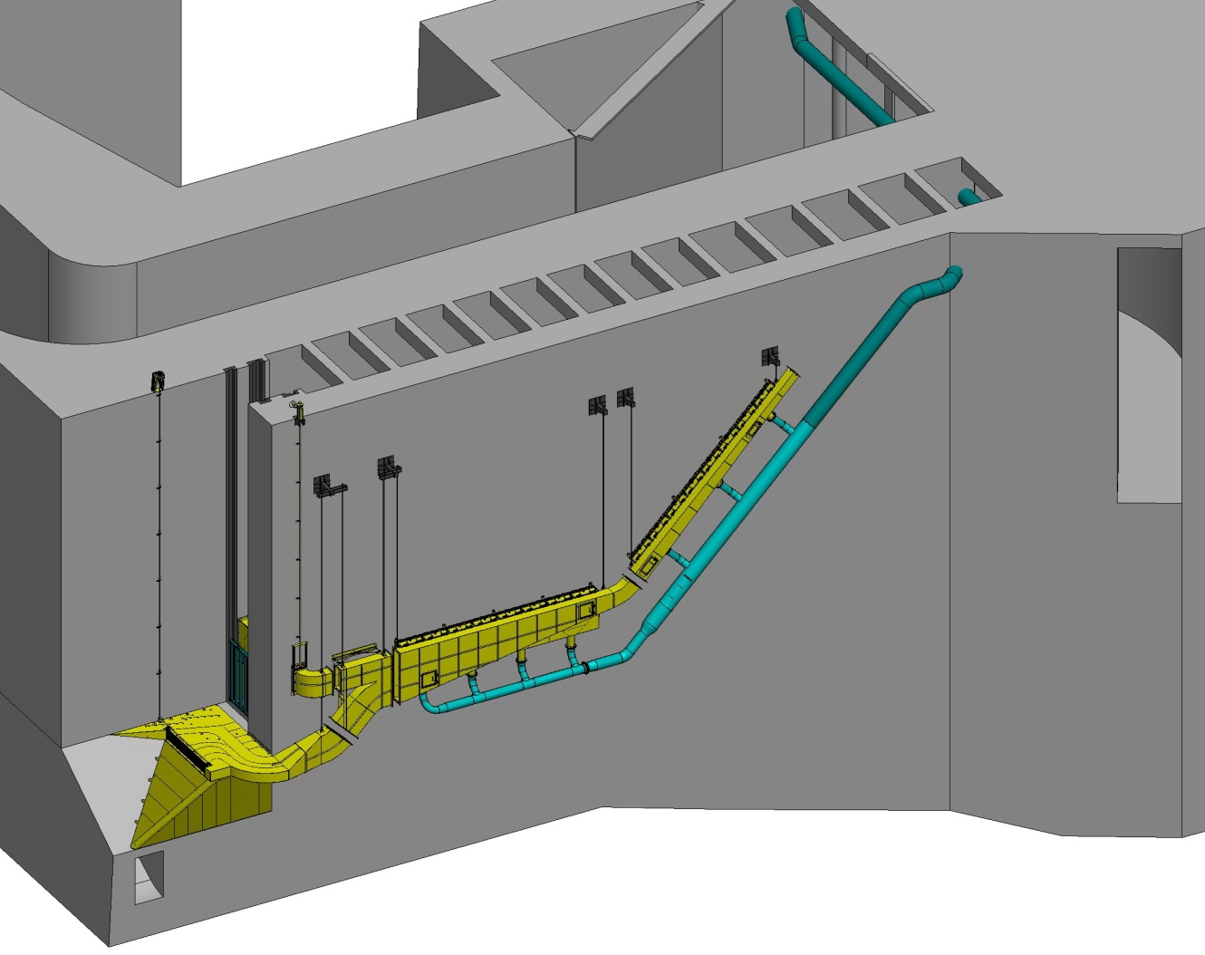
The mounting system for the Lamprey Flume System (LFS) consists of vertical hanging rods. COE is concerned that these will fail if not modified during the proposed work period.

Figure 1. Isometric rendering of the Lamprey Flume System (LFS) with gravity flow water supply system. During the proposed work period, COE intends to modify the mounting/support system for the LFS, secure HDX-PIT conduit, and install permanent mounting hardware for the pumps that supply water to the adjacent LPS (not shown).

Figure 2. Conceptual design for permanent LPS pump system. A davit will be used to raise and lower pumps (including hoses shown in green and electrical conduit shown in purple) down i-beams via trolleys. Pumps supply water to the LPS ramp and collection tanks at the top of the Lamprey Flume System. Installation during the proposed work period would involve securing i-beams to the west wall of the WA Shore monolith (in place of current temporary pump system). Design details will be shared with FPOM as they are developed.

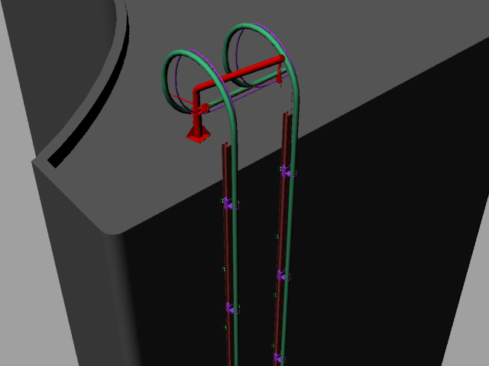

Table 1. Passage of adult salmonids at Bonneville Dam from October 15 through November 12 (2004-2012 counts).

Passage at Bradford Island Fish Ladder (October 15 - November 12)
Year | Chinook | Steelhead | Coho | Chum | Ladder Total | BON Total | % of Total BON
2004 | 3218 | 1083 | 2293 | 4 | 6598 | 27881 | 23.7%
2005 | 3512 | 2719 | 2781 | 87 | 9099 | 20594 | 44.2%
2006 | 4044 | 1296 | 5005 | 11 | 10356 | 35310 | 29.3%
2007 | 1938 | 712 | 3160 | 21 | 5831 | 28855 | 20.2%
2008 | 1201 | 537 | 2977 | 17 | 4732 | 20083 | 23.6%
2009 | 1040 | 1171 | 6419 | 12 | 8642 | 53011 | 16.3%
2010 | 1561 | 783 | 5315 | 16 | 7675 | 31455 | 24.4%
2011 | 5945 | 1853 | 3682 | 11 | 11491 | 19074 | 60.2%
2012 | 1656 | 1578 | 1648 | 4 | 4886 | 19835 | 24.6%
Mean | 2679 | 1304 |  |  | 7701 | 28455
% Mean Passage |  |  |  |  |  |  | 29.6%
Passage at Washington Shore Fish Ladder (October 15 - November 12)
Year | Chinook | Steelhead | Coho | Chum | Ladder Total | BON Total | % of Total BON
2004 | 6624 | 2806 | 11853 | 0 | 21283 | 27881 | 76.3%
2005 | 3710 | 3430 | 4327 | 28 | 11495 | 20594 | 55.8%
2006 | 7766 | 5817 | 11272 | 99 | 24954 | 35310 | 70.7%
2007 | 4252 | 2802 | 15925 | 45 | 23024 | 28855 | 79.8%
2008 | 2921 | 1818 | 10571 | 41 | 15351 | 20083 | 76.4%
2009 | 4235 | 5389 | 34682 | 63 | 44369 | 53011 | 83.7%
2010 | 4790 | 1891 | 17022 | 77 | 23780 | 31455 | 75.6%
2011 | 4354 | 660 | 2563 | 6 | 7583 | 19074 | 39.8%
2012 | 5675 | 2363 | 6869 | 42 | 14949 | 19835 | 75.4%
Mean | 4925 | 2997 |  |  | 20754 | 28455
% Mean Passage |  |  |  |  |  |  | 70.4%

Figure 3. Mean daily salmon and steelhead passage at Bonneville Dam during the proposed work period (2004-2012).

